Your invitation to join us to organise & celebrate Australia Day 2016
@ the Balla Balla Centre in Cranbourne
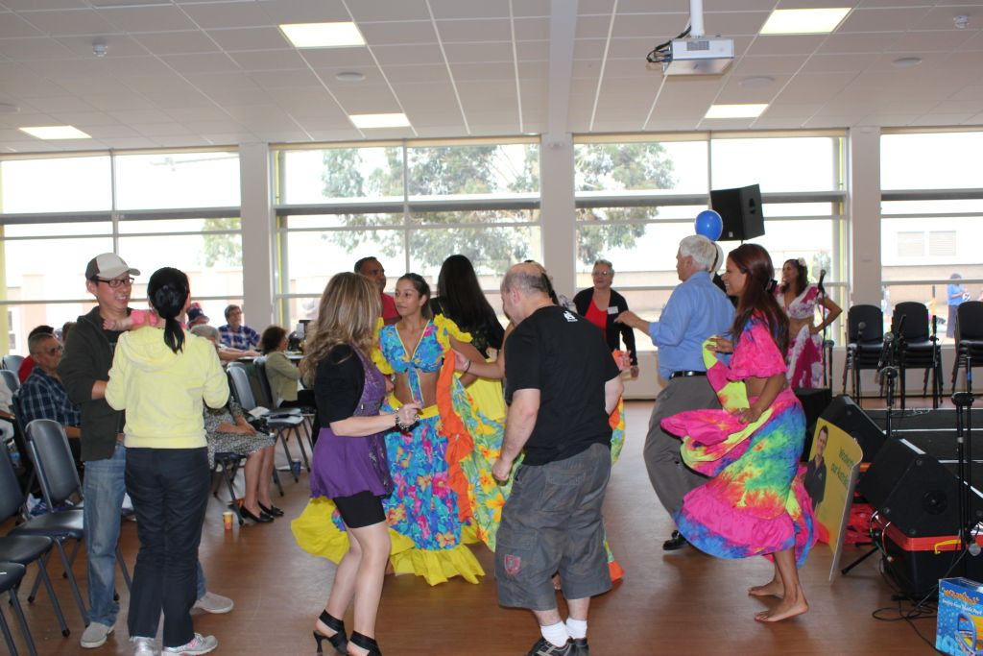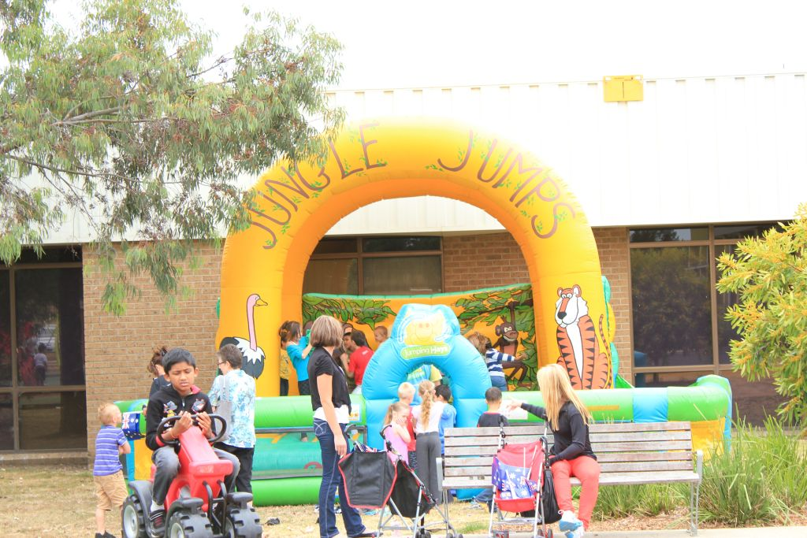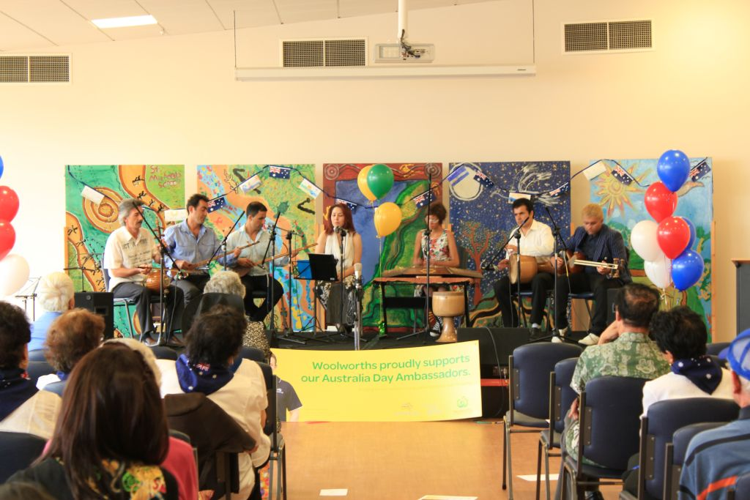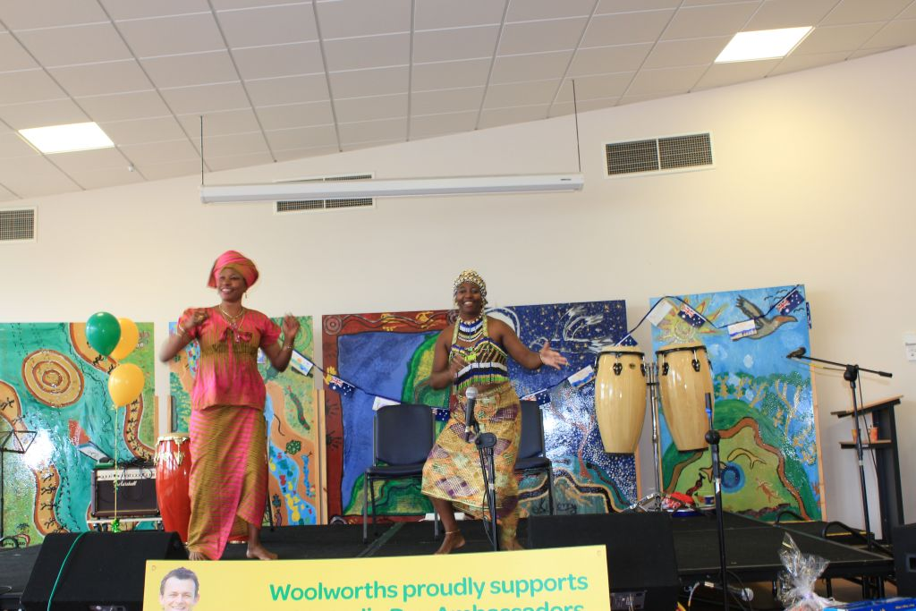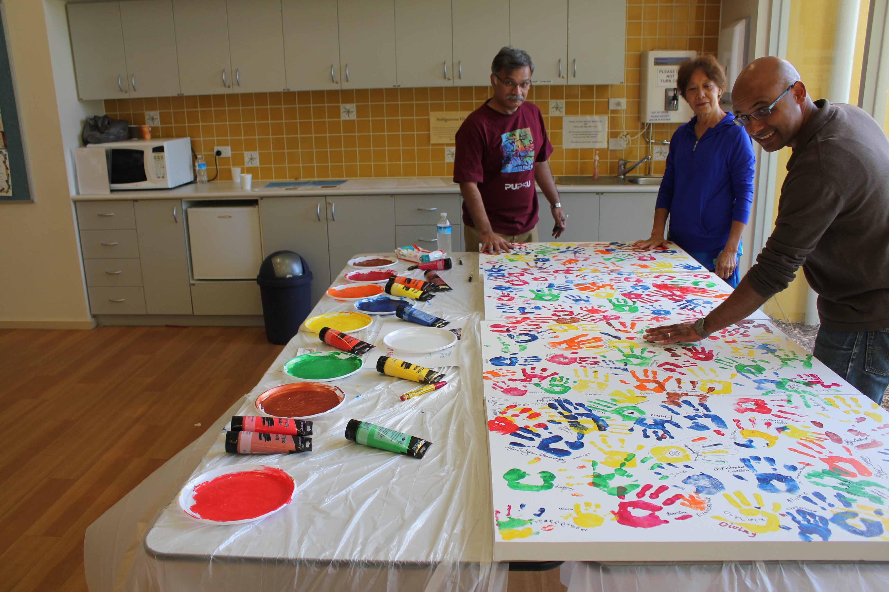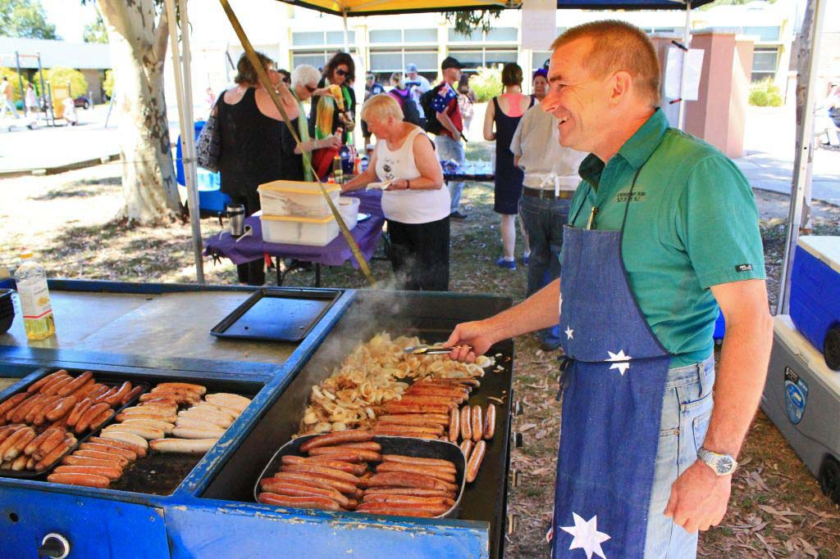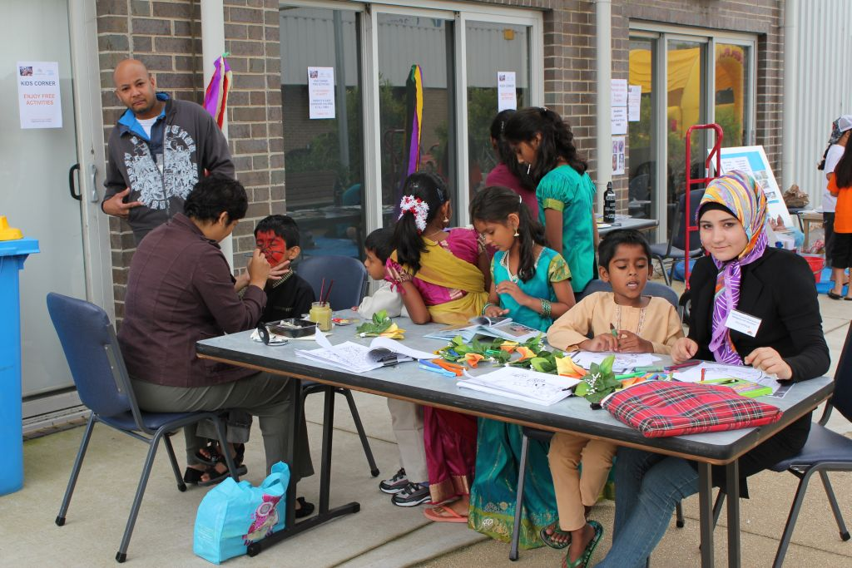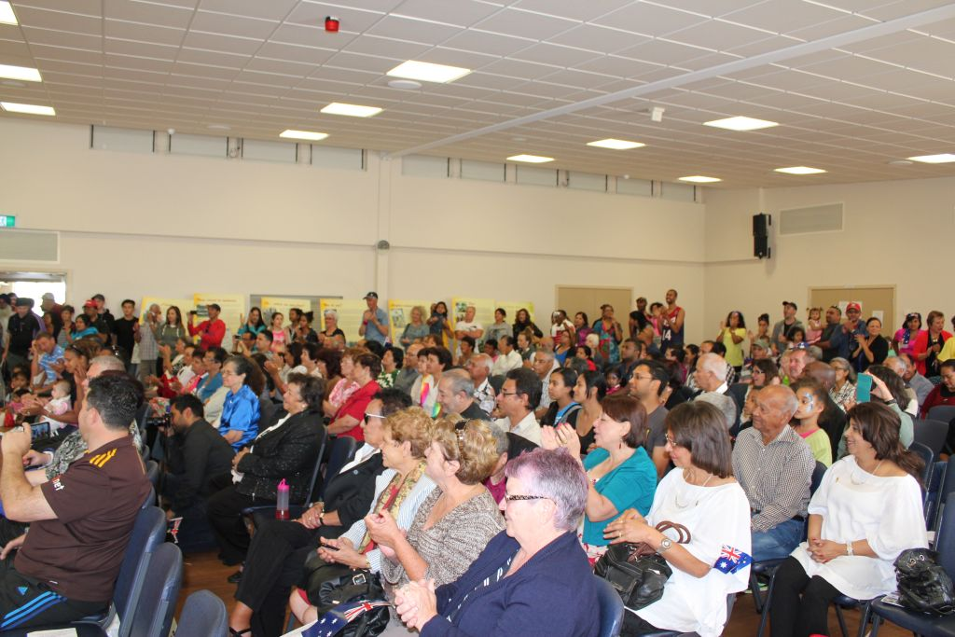
Photos courtesy of CHARM Vic, Previous Australia Day Celebrations – Cranbourne event

This is another great opportunity for all of us to celebrate what makes Casey and our country so wonderful!
The Cultural Historical Association of Rodriguans & Mauritians in Victoria (C.H.A.R.M Vic) in collaboration with various community groups and individuals will once again host the Passport to Casey’s Cultural Heritage Showcase,
a FREE family event showcasing our rich and diverse cultural heritage and what makes us proud to live in the City of Casey.

How can you play a part?

- Express your interest to be involved!

Contact us by Monday 30 November 2015 if you can be involved. Volunteer your time and/or talent (dance, sing, paint, drum, cook and more) and be part of this inclusive community celebration

- Save the date now - join us on Tuesday 26th January 2016
Time: 11:00 AM - 4:00 PM (TBC)
Address: Balla Balla Centre, 65 Berwick-Cranbourne Road,
Cranbourne East

The event will include:

- a free sausage sizzle, food tastings (halal & vegetarian options also available)
- traditional music/dances, drumming, a cultural exhibition, exhibition, workshops
- lots of free children’s activities and more.

For more details:

Call: Edwige 0418 367 417 or email: president@charm.org.au
Visit www.charm.org.au for regular updates

If you need help filling in the forms, please call us.

Note that all requests to perform and/or have a stall/display will be subject to the committee’s approval and will need to meet all risk/safety requirements and legal obligations.
We aim to have a draft program issued for feedback in Dec 2015. Final event details and program to be confirmed 2 weeks prior to the event or earlier(may be subject to change depending on circumstances beyond our control). The organisers will liaise with key contact regarding the outcome of your expression of interest, any requirements, changes etc.

EXPRESSION OF INTEREST (EOI)
PERFORMING GROUPS

- General Details
Type of group (Please tick):

Choir or Band |  | Dance Group |  |  |  | Theatrical Group
Solo Singer |  | Other, please provide details:
Performing Group name:
Contact name:
Phone: |  |  |  |  |  | Mobile:
Email:
Address:
Group or individual Profile/Bio:

Description of performance:
Duration of your performance  (Please tick):  We do our best to accommodate all requests, however as this is a community event and we want to be inclusive in engaging as many as possible, we may not be able to provide the requested timeframe. We will confirm this 3 weeks prior to event date |  |  |  | 5min 10min 15min Other request:___________
Number of people performing on the stage: |  |  |  |  | (Maximum of 15)

- Sound Requirements
Technical requirements

Do you require a microphone for your performance: | Yes No
Number of microphones required: | 1 2
Please specify the type of microphone you require: | Handheld Wireless  Handheld Cord
Do you require a CD Player: | Yes No
Will live music be part of your performance? | Yes No
If yes, describe the instruments used for this live music:
Are there any other technical requirements you have for your performance:
Do you have any special accessibility requirements to access the stage and/ or event site: (If so please provide details)
- Agreement
I have read the information and I agree to comply with the Terms and Conditions and to work closely with the organisers to make this event fun, safe and successful for all.

Signed
(Type full name if completing electronically)
Name
Group/ Company
Date

EXPRESSION OF INTEREST
STALLHOLDERS/DISPLAY

- General Details
Type of group (Please tick):
Arts/Crafts |  |  | Collectables |  |  | Educational
Clothing |  |  | Other, please state:
Group/company name:
Contact name:
Phone: |  |  |  |  |  | Mobile:
Email:
Address: |  | Postcode:
Description of stall content (please be specific):
Size you require for your stall in (i.e. 4m wide by 2m deep):
Extra equipment requirements (you will be provided with one table and two chairs):

All stalls/display will need to be supervised by your volunteers. We are not responsible for valuable items, so please keep them safe and don’t leave these unsupervised. All equipment must be safety checked and tagged.
Whilst we do not charge a set fee for community groups, not for profit businesses and individuals to be involved, a donation towards the event activities and door prizes is appreciated. A small fee may apply for commercial businesses. All expressions of interest will be reviewed by the organising committee and are subject to their final approval. You will be advised by mid to end of November 2015.
If you have any questions please contact us.

- Power
Power Points are limited around the perimeter of the hall. Please indicate whether your stall/display requires the use of a power point socket.
Yes No
- Insurance
Whilst all care is taken we will not accept any liability for equipment that is lost, stolen or damaged whilst on the event site for the duration of Tuesday 26 January 2016.
All stallholders must have current personal/business insurance cover for loss of, damage to and theft of property.
- Agreement
I/We accept the terms and conditions for this event and will work closely with the organisers to make this event fun, safe and successful. I/we agree to comply with the Terms and Conditions.
Signed:
Name:
Group/ Company:
Date:

Thank you for your interest

We look forward to your involvement and positive contribution.
Together we can make a difference

