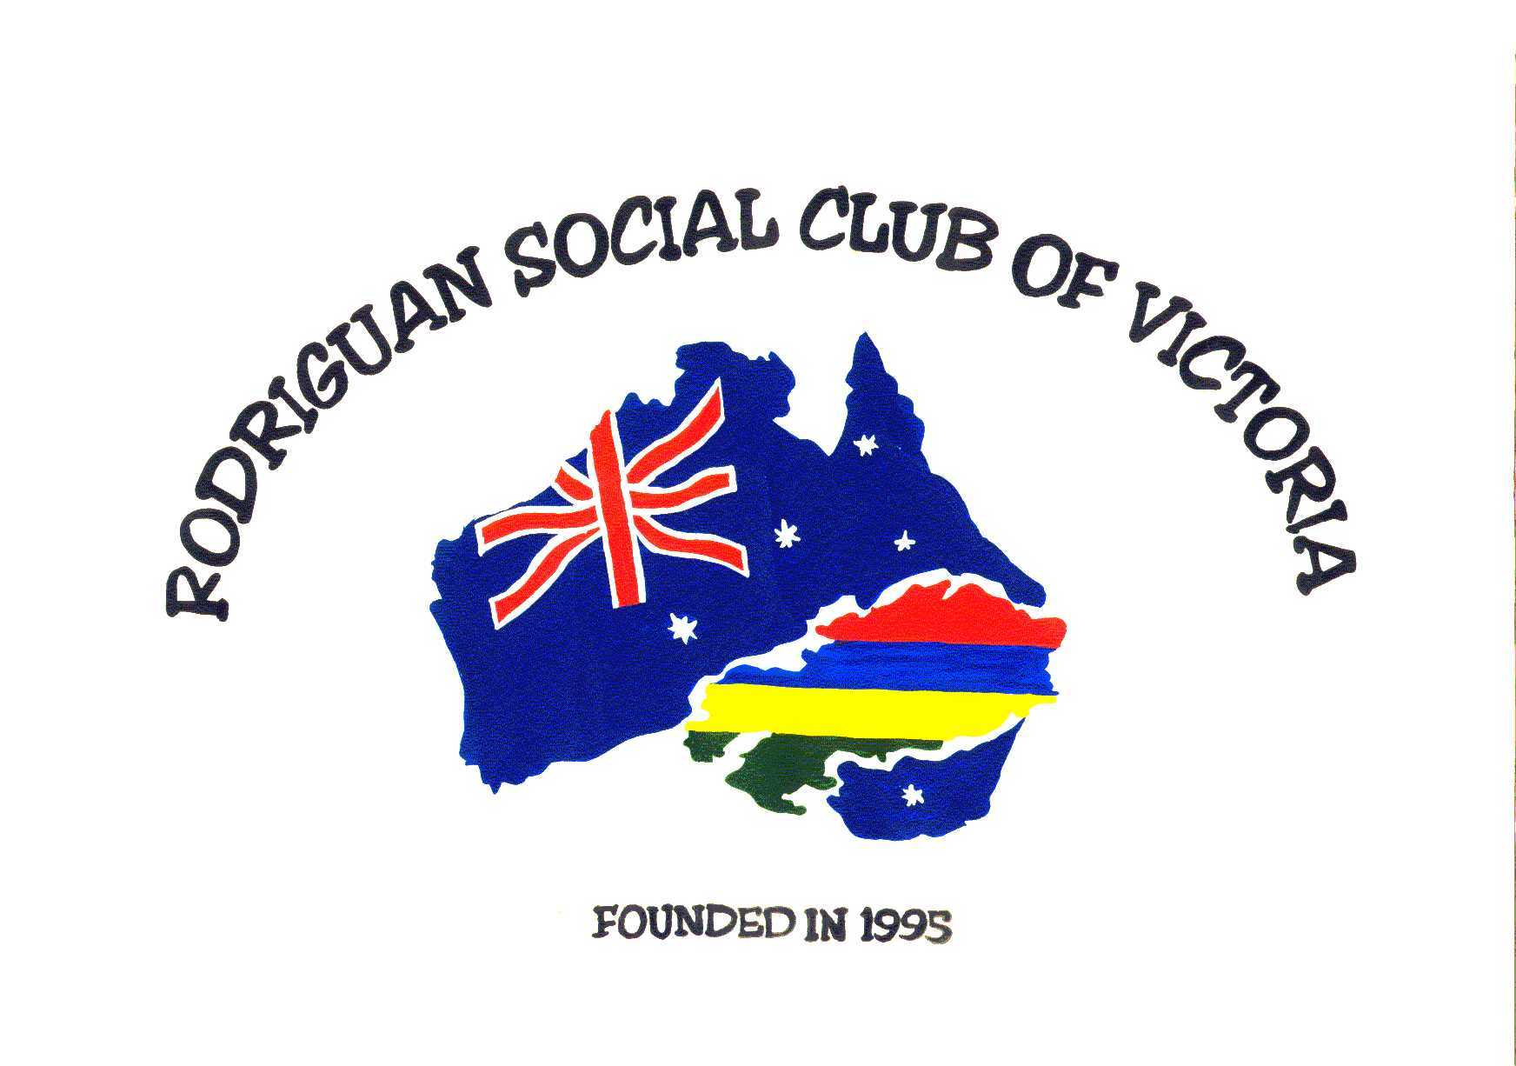
P.O.BOX 55,
Bourke Road,
CLARINDA, 3169
Website: users.bigpond.rscv/com
Email: rscvic@yahoo.com.au
To raise much needed funds for the clubhouse project,
The Rodriguan Social Club of Vic
In Conjunction With CHARM
Invite you to their
Autumn Festival
On Sunday, 18th May 2008 at
St Anthony’s Hall, Buckley Road, Noble Park
From 12.00pm to 7.00pm
(Mass at St Anthony’s church is 11.00am, if you wish to attend)
Donation/Entrance Fee: $3.00 for adults
Children; $2.00 (6yrs to 12yrs)
(we charge a small fee to cover expenses)

PLEASE DO NOT BRING ANY DRINKS
Menu creole/Drinks, Chilli, Pickles & Delicious cakes
(Napolitaine, Gateau patate, piaw, pistache, gingelie and tourtre) will be on sale

Highlight of the Afternoon will be:
Floorshow of different performers, Concert, Fashion Parade
including Bric-a-brac stall and a few club’s displays.

Please come along and bring your friends to support us. Thank you

For more information, please contact: Fidou Templin on 9512 7342, Patricia Kimtia on 0403 206 735, Annecy Hotunam on 9799 0172, Cyril Appadoo on 9799 2294 or Michael Plaiche on 0401 251 582.
“Together We Create A Better Family “

