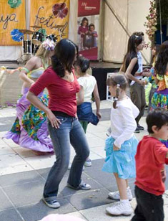
La Faya Festival 2007 – Immigration Museum
Photographer: Rodney Start
La Faya, meaning to party is set to do just that!
In 2008, this colourful & exotic community festival coincides
With the Moomba Waterfest Celebrations
It will be a celebration of Cultural Diversity in harmony
The Mauritians & Rodriguans in Victoria and several other communities will unite to showcase their rich, diverse and colourful cultures with live entertainment and performances of traditional Dance and Songs, exotic food, a Kids Corner, a Health Corner, demonstrations of traditional games and an exhibition exploring the history of the community’s migration and settlement in Victoria.
The Mauritians & Rodriguans have significantly contributed to Victoria’s multi-cultural society, boasting a population of 18,175 Australia-wide, with the majority, 9,047 ‘Mauritian-born’, residing in Victoria. (ABS Census 2006). Since the 18th Century, the islands of Mauritius & Rodrigues have been known for integrating people from diverse cultural and religious backgrounds. With commonly practiced religions, Christianity, Buddhism, Islam and Hinduism, and an ancestral mix of Europe, Asia and Africa. It is no wonder, these islands are regarded as being peaceful and respectful multi-cultural communities.
Mauritians & Rodriguans have managed to move beyond ‘tolerating’ differences….to genuinely respecting and understanding that each culture brings knowledge which help to shape the future.
“We are proud and delighted of our accomplishments & contribution to the wonderful state of Victoria. We wish to celebrate this, and share our experiences
and cultural heritage with all.”
So, come ‘La Faya’ with us”

La Faya Festival is proudly
supported by

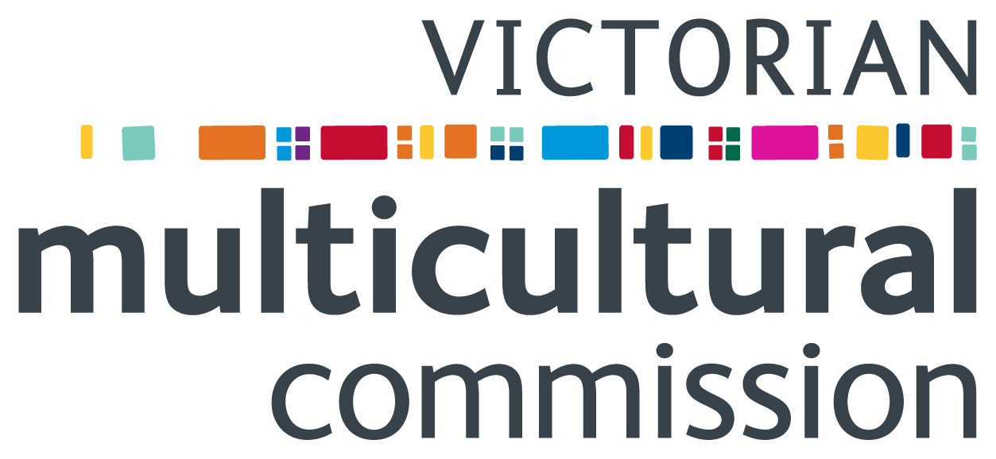

Mauritian Golden Age Club

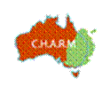
www.charm.org.au www.federationsquare.com.au

Radio 3ZZZ & 3SER Mauritian programs
SBS French Program

Special thanks to community members who helped with fundraising efforts,
especially the dance organisers & guests,
& those who sold Raffle tickets

“Together we can continue to
make a difference”

La Faya Festival
Program

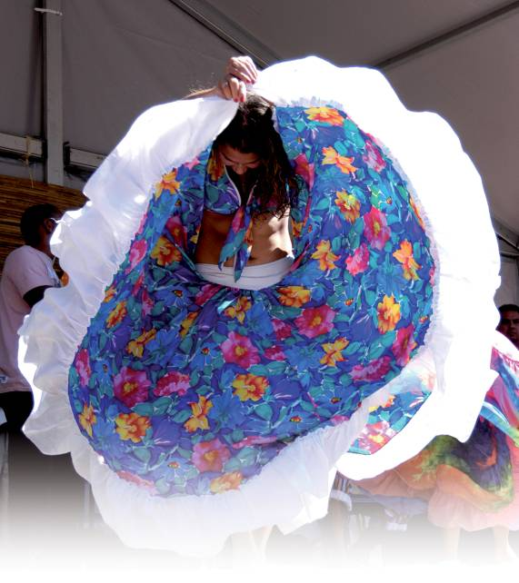

Photo courtesy of Henri D’Argent

Sunday 9 March 2008
@ Federation Square Melbourne

10am till late

The Mauritian community celebrates
40+ years of migration and proudly showcases diversity in harmony

Cultural Performances from 10 am till late
BMW Edge - Official Opening 10am – 11.10am
The Square – Main stage 11.10am onwards
10am | Official Opening
10.10am | Mauritian Golden Age Choir
10.20am | Festa Nova Choir – Music of the world
10.35am | Mauritian Golden Age Line Dancers
10.45am | Jennifer-Marie – Popular English songs
11.am | Claude Allas – French opérette & classic songs
11.10am | Seychelles Tropical Honeys – Traditional Dances
11.20am | Michelle Smith – Pop, R&B
11.30am | Steve Benoit – Popular love songs
11.40am | Jean Cabon – African/Mauritian fusion of rhythms
11.50am | Les Petites Pinguettes - Séga dance
12.05pm | Camino – Latin influence Trio
12.25pm | Rodney Pilois – Drumming, roving entertainment
12.35pm | Leo Grancourt – French & English songs
12.45pm | Daniel Bonne - Violonist
12.55pm | Racine Kreole – Séga dance
1.05pm | The Joyful Singers/La Riviere Tanier Singing Group –Séga and Chansons Creoles (Medley Creole)
1.15pm | Partaze nou Kiltir – Rodriguan traditional dance
1.25pm | Terence – R & B
1.40pm | Days in the Diocese (DID08, WYD) Guest Performers*
1.55pm | Jean Robert & Carole – Popular English songs
2.05pm | Nikki Desveaux – R&B, Pop
2.15pm | Natya Bollywood dancers
2.35pm | Les Petits Piments – Sega dance
2.45pm | Shane Robert – R&B
2.55pm | Priscilla Leveque – Pop
3.05pm | Funky Avenue – Band
3.20pm | Papa Kwasi – Reggae band
3.35pm | Kunasuc (Sego Lebrasse & dancers) – Séga traditional dances & songs
3.50pm | TnT – Hip Hop style dance group
4.05pm | Mario Gentil –Popular English & French songs
4.15pm | Les Flamboyants girls – Séga dancers
4.25pm | Ti Marmites – Séga dancers
4.40pm | MCSV Lindsay Min Fa & dancers (Traditional Chinese dance and song)
4.50pm | MCSV Davis Kim Lim and Valerie
5.00pm | MCSV Lindsay Min Fa
5.10pm | Sunset Band – Edy & Jason Heerah
5.30pm | Rodriguan Social Club of Victoria – Rodriguan Traditional dance & Séga dance )
5.45pm | Creole Illusions - mix of the old & the new Séga dance
5.55pm | Dynasti - Band
6.10 pm | Tropical Vibz – Band
*©2007 guyTunes Pty Limited and Gary Pinto. Performed with permission of World Youth Day 2008 under licence by guyTunes Pty Limited and Gary Pinto
7pm - BMW Edge – Grand Finale - Join us for more fun…St Anthony’s Choir,
L’Arc-en-Ciel (a short musical showcasing the rich cultural heritage of Mauritius),
Creole Illusions dancers…
Many surprises in store…La Faya continuer!

Raffle draw
The Square - Kids Corner
Traditional storytelling and kids activities

10.45am – 5 pm

Hear traditional Mauritian stories told in French and
English, and nursery rhymes in Kreole and French.
Face painting, colouring and other children’s activities

The Square - Community Information & Displays

10am – 5 pm
Learn more about our vibrant community and the
Mauritian, Rodriguan and Seychelles people in
Victoria (social & sporting clubs, charities)

The Square - JCL Mobile Airbrushing Marquee 10am – 6pm - Airbrushing Art & Temporary Tattoos
(check out the stage back drop kindly donated by Jack Lubin)

Swanston Street Entrance – The Food Corner

11am – 5 pm

Traditional Mauritian snacks, meals, sweets
and drinks available from Le Bon Café, Lucy’s Divine Cakes (ex Cocotier Café) and AVETA

BMW Edge - Throughout the day
- Film/documentary/slide show screenings

Talks (time TBA on the day)
- 12.30: Ageing, Challenges & Joys - Irlande Alfred
- 1.00pm: About the Stella Clavisque Club- Vice President Orietta Wheatley
- 1.30pm: The Chinese Community in Mauritius,Australia and Rodrigues. La Crosiere, Rodrigues La Visite Patrick Morel
- 2.30pm: Reinventing One Self-Dr Danielle Tranquille
- 3.30pm: First world surgery for kids of the world,Prof. Patrick Dewan, Kind Cuts for Kids

The Reading/research corner – all day:
Be inspired to:
- Explore the history of Mauritians and Rodriguans who have immigrated to Victoria
- Share your personal migration stories
- Resources & some interesting books will be on display

“Down Memory Lane” photographic display –
all day
See various historical photos of
- Mauritius & Rodrigues
- our community in Australia

Dance and music workshops

- 12.00: Play the ravanne & other traditional musical instruments from the islands of Mauritius & Rodrigues
- 12.30: Learn to dance the Sega
- 1.30pm: Dance the Kotis, traditional Rodriguan dance
- 3.00pm: Learn the Cha Cha Cha with
Lindsay Min Fa
- 4.00pm: Learn the Lancier (court dance)

Roving Entertainment

- Drumming and dancing around Federation Square

The Atrium

10am – 5 pm

Don’t forget to see: Beyond the Postcard Image:
Mauritians and Rodriguans in Victoria
Historic exhibition held in the Community Gallery at the Immigration Museum from Nov 06 – March 07- if you missed it here is your chance to see this exhibition.
Brought to you again courtesy of the Immigration Museum and CHARM

Reunion Corner
Those who travelled from the mid 50s to early 70s, and anyone else willing to reconnect and meet with those they might have travelled with!!!

Program subject to change without notice – Thurs 06.03.08

